SLOW ART DAY, APRIL 12, 2014
10-12 a.m. VIEW FEATURED ART IN THE “PAINTING BORGES” EXHIBITION
12-1 p.m. LUNCH AND DISCUSSION IN THE CAFÉ
(BRING A SACK LUNCH, DESSERT AND COFFEE PROVIDED)

Carlos Estévez, Agujero en el tiempo (Hole in Time), 2011, pencil and gouache on paper

Additional works:
Mirta Kupferminc, El milagro secreto (The Secret Miracle), 4/5, 2008, digital print
Laura Delgado, La otra – éramos demasiado parecidos y demasiado distintos (The Female Other – We Were too Similar and too Different), 2009, mixed media on canvas
Héctor Destéfanis, Ruinas circulares II (Circular Ruins II), 2009, mixed media on paper
Luis Cruz Azaceta, La casa de Asterión (The House of Asterion), 2009, markers on paper

It’s not what you look at that matters, it’s what you see.
Henry David Thoreau

Slow Art Day is the global all-volunteer event with a simple mission: help more people discover for themselves the joy of looking at and loving art.
Why Slow?
When people look slowly at a piece of art they make discoveries.
The most important discovery they make is that they can see and experience art without an expert (or expertise).
And that’s an exciting discovery. It unlocks passion and creativity and helps to create more art fans.
How Does It work?
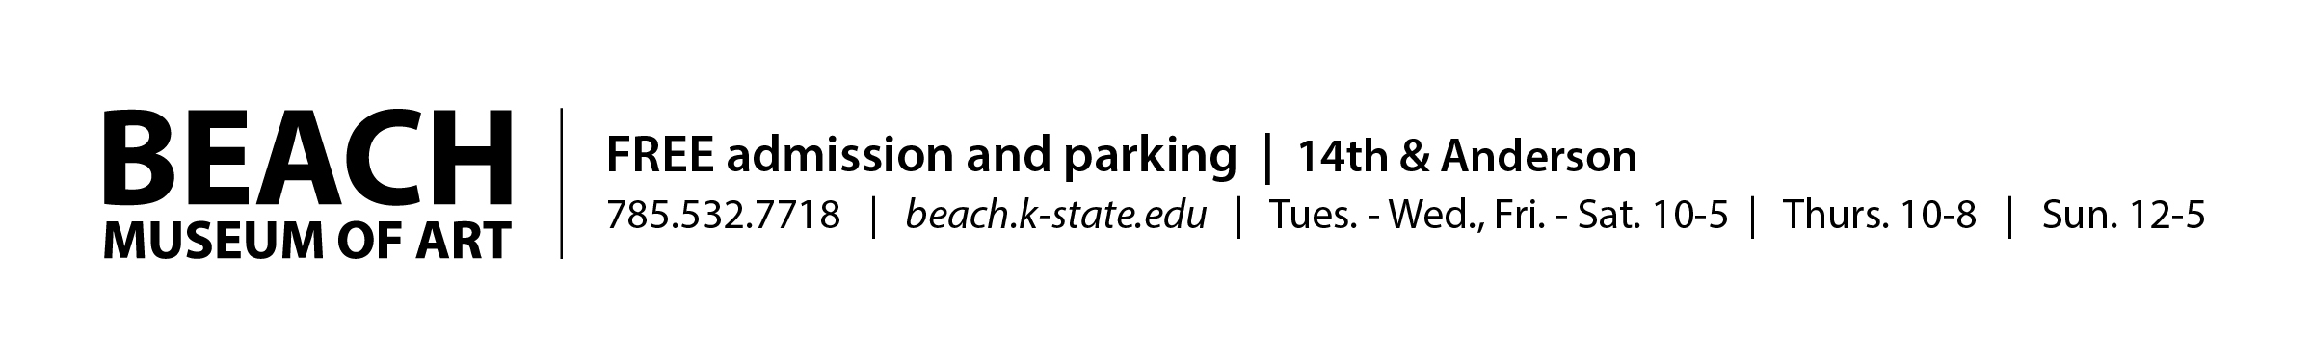
One day each year, people all over the world visit local museums and galleries to look at art slowly. Participants look at five works of art for 10 minutes each and then meet together over lunch to talk about their experience. That’s it. Simple by design, the goal is to focus on the art and the art of seeing.

